COMPUTER FUNDAMENTAL LAB REPORT # 2

NAME | Haseeb Riaz
REGISTRATION  NUMBER | BF25NWELE0697
DEPARTMENT | ELECTRICAL ENG  (AI)
SECTION | “B”
SEMISTER | 2nd
SUBJECT | COMPUTER  PROGRAMING

Objectives
The primary goal of this session was to establish a fundamental understanding of C++ syntax Key learning outcomes included:
- Implementing the basic boilerplate structure of a C++ program.
- Managing Standard I/O (Input/Output) using cin and cout.
- Applying appropriate Data Types and Arithmetic Operators.
- Practicing industry-standard indentation and documentation (comments).

Technical Summary
- Basic Syntax & I/O
Every functional C++ program requires the #include <iostream> header and a main() function.
  - cout <<: Used for displaying data.
  - cin >>: Used for capturing user input.
  - endl: A manipulator used to insert a new line.
- Data Types
C++ requires explicit declaration of variables. The following were utilized:
  - int: For whole numbers.
  - double: For high-precision decimal values.
  - char: For single characters (using single quotes).
  - bool: For logical True/False.
  - string: For text sequences.
- Arithmetic Operators
Calculations are performed using:
  - Addition (+), Subtraction (-), Multiplication (*).
  - Division (/): Note that integer division truncates decimals.
  - Modulus (%): Returns the remainder of a division.

EXAMPLE # 1
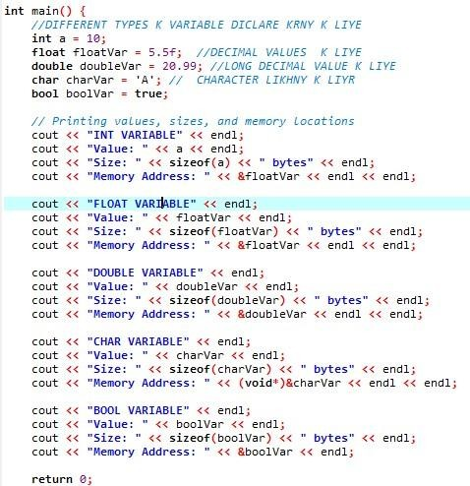
EXAMPLE # 2
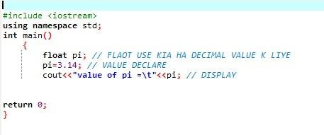

EXAMPLE # 3
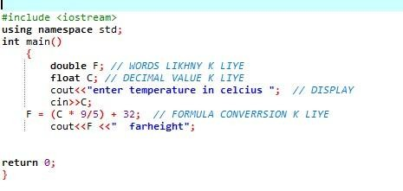

END

